Activity Report SPIC 730

https://drive.google.com/drive/folders/1g5NWvV3SS4ZXAY4RV1Aun1_cVOBbHp3L?usp=sharing

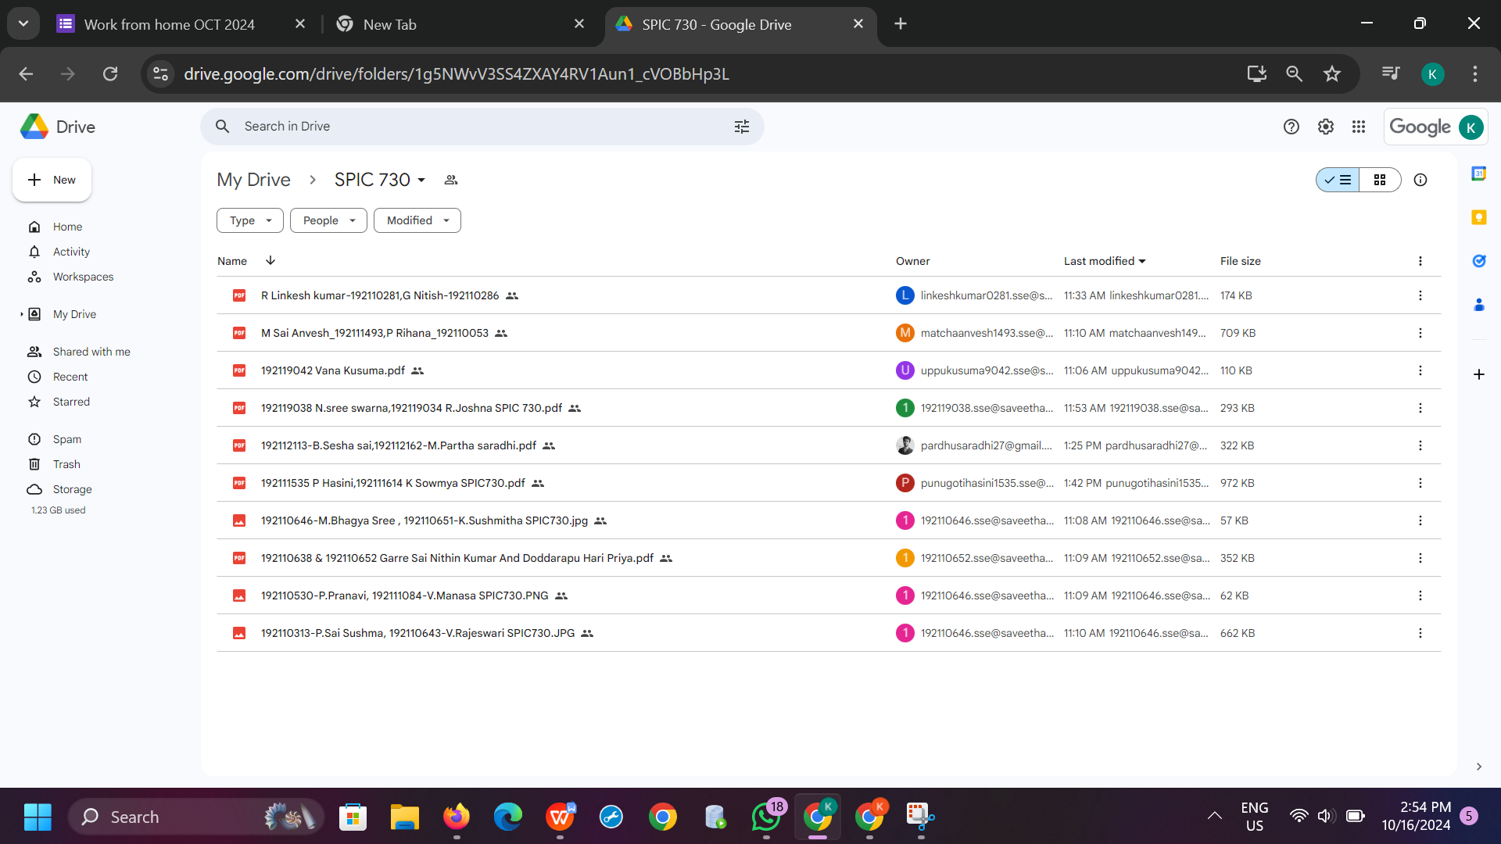

Activity Report SPIC 729

https://drive.google.com/drive/folders/16mQBO1HB1OvSy4noxMMhXrGKeRndxnLY?usp=sharing

